

August 29th, 2016

**Rep Alert**

**A40B shunt promotion with 5790B purchase**

Dear Sales Partner,

Please find below all the details on a promotion with the A40B shunts when purchased together with the 5790B

**Customer promotion**

**Purchase A40B shunts together with the 5790B and you will save 20% on the A40B shunts.**

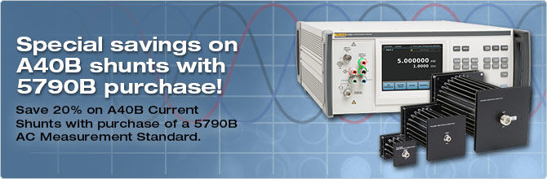**Time frame**:   
September 1st – December 31st, 2016

**How to promote:**

* Promotional webpage and banner on FCAL website:   
  <http://eu.flukecal.com/node/90511>

<http://eu.flukecal.com/de/node/97752>

<http://eu.flukecal.com/fr/node/97753>  
<http://eu.flukecal.com/es/node/97755>

<http://ru.flukecal.com/node/97756>

* Promotional banner on distributors’ websites.  
  If you need the banner in local language or in a different size,  
  please contact gerda.meijer@flukecal.com
* 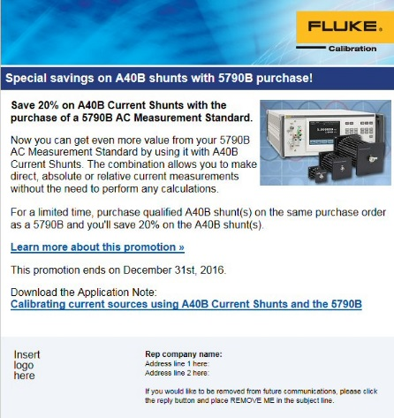Html mail to end customers  
  Please send to your own customer database

### How to order: Place your order with the text A40B-SHUNT-PROMO

With kind regards,

EMEA Fluke Calibration Team